**Romibo Project**

* **Equipment**: Monitor, CHIP, two USB cables, RCA cables, and power cable

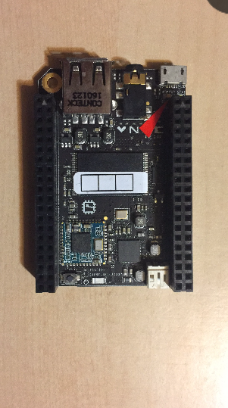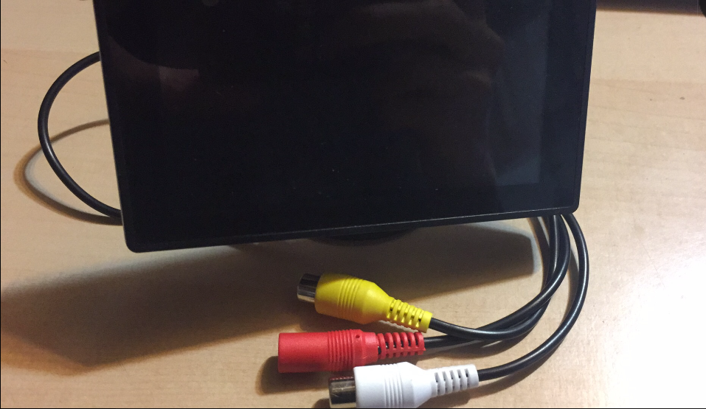

Image 1: CHIP Image 2: Monitor

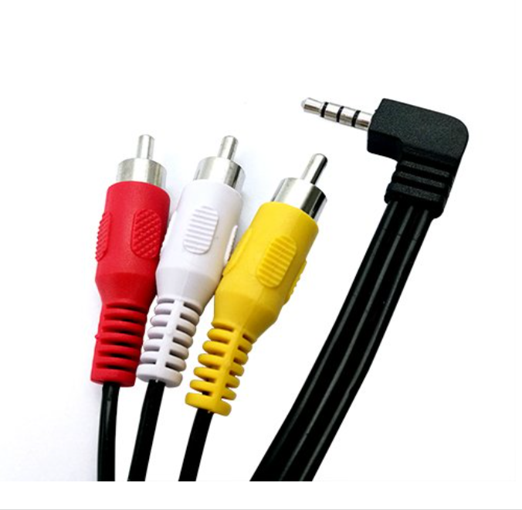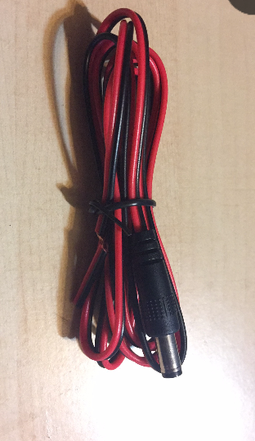

Image 3: RCA cables Image 4: Power cable

* **Flash CHIP**

The Chip must be flashed before using. The following website will show you how to flash the CHIP step by step:

<http://flash.getchip.com/>

**Reminder: The following steps will show you how to setup 5V monitor**

* **How To Connect:**

1: Before start connecting all the cables with the CHIP, you need to connect one side of a USB cable with power cable. By doing that, cut out the USB cable in the first place and you will see there are four wires with different colors inside(Image 5).

2: Take out the rubber layer of red and black wires of both the USB cable and power cable(Image 6).

3:Soldering: Soldering the wires with the same color together(Only red and black), then attach rubber to the wires (Using heat gun) so that the wires are insulated from outside.(Image 7)

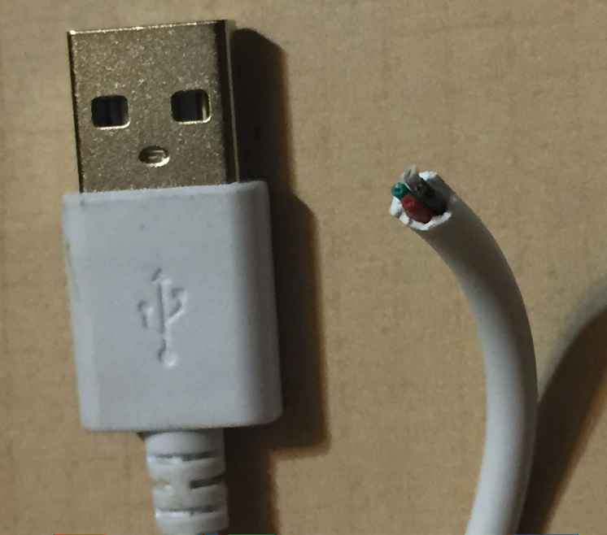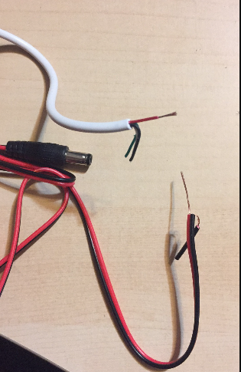

Image 5 Image 6

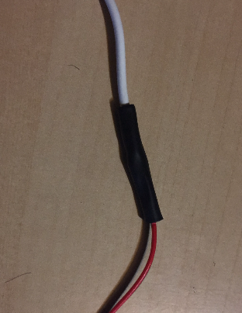

Image 7

4: Now start connecting cables with the CHIP and laptop:

- Connect RCA cables and USB cable( non-refurbish one) to the CHIP(Image 8).

- Connect the refurbished USB cable to the laptop.

- Connect the the yellow and white RCA cables of the monitor with the RCA cables that have already been connected with the CHIP on the first step (Connect with the same color). Then connect the power cable to the red RCA cable of the monitor(Image 9)

- The last step is to connect the non-refurbished cable to the laptop to provide power supply to the CHIP. Now, the CHIP should be powered on and LED on the CHIP should light up. The monitor starts to display image.(Image 10)

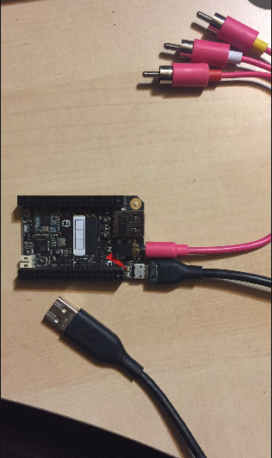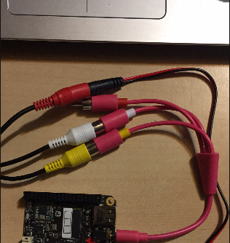

Image 8 Image 9

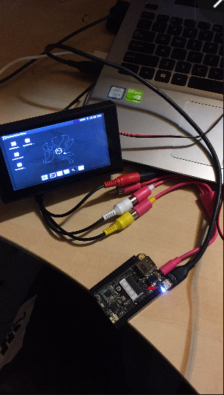

Image 10

**\*We do not use the red RCA cable at this point, so it does not connect to anything.**

**Reminder: Step 5 will show you how to setup 12V monitor**

The difference between 5v monitor connection and 12v connection is that we need a few more materials before making connection: A breadboard, A boost converter, and a few wires. In addition, we do not need to soldering the power cable with a USB cable.

5: Now start connecting cables with the CHIP, laptop and breadboard: (Pretty similar with 5v monitor connection)

- Put the converter on the breadboard so that “IN+” and “OUT+” connect to the power pins, “IN-” and “OUT-” connect to the ground pins.(Image11)

- Connect the red wire of power cable to the power pin on the breadboard, then connect the black wire of power cable to the ground pin on the breadboard.(Image11)

- Connect another USB cable to the ground and power pins, the other side connects to the laptop(Image 12: blue and green wires come from the USB cable, white and brown wires come from power cable)

- Connect RCA cables and a USB cable to the CHIP(Image 8).

- Connect the other side of power cable to the red RCA cable of the monitor.

- Connect the the yellow and white RCA cables of the monitor with the RCA cables that have already been connected with the CHIP on the first step(Connect with the same color). Then connect the power cable to the red RCA cable of the monitor(Image 9)

- The last step is to connect the non-refurbished cable to the laptop to provide power supply to the CHIP. Now, the CHIP should be powered on and LED on the CHIP should light up. The monitor starts to display image.(Image 10)

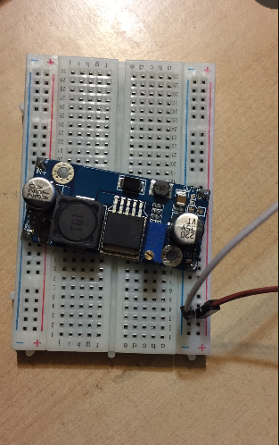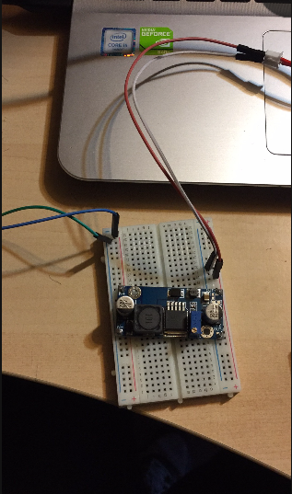

Image 11 Image 12

* **CHIP Setup and Installation**

This is an important step to show you how to setup the CHIP completely so that it can run the Romibo Program.

1: Right click the mouse and click “Open Terminal here”, then the monitor will open a terminal for you.

2: Type “sudo apt-get install git-all” to install git.

3: Type “sudo git clone [https://github.com/weetinygit/Romibo-V8”](https://github.com/weetinygit/Romibo-V8\”)

What this command does is to upload all the documents from github to the CHIP. (All the documents of Romibo Program has been uploaded on github)

4: Type “cd /home/chip/Romibo-V8/Bash_files” to change the file directory. Then type “sudo bash romibo.sh” to install all applications and software. It may take a few minuets to finish installation.

5: After installation, we use Crontab to run Romibo program, such as showing eyes emotions and producing voice.

Here is the instruction (Do it on the terminal)

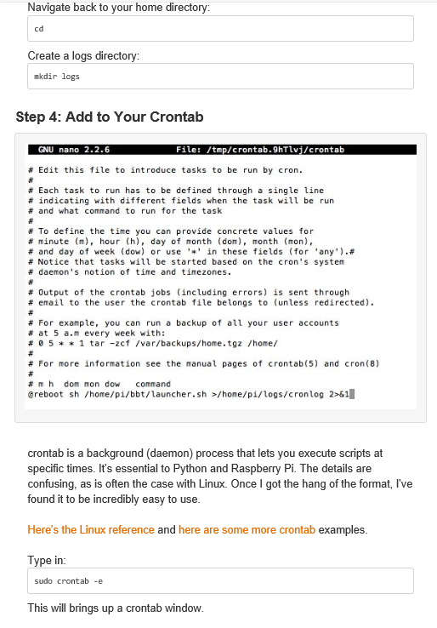

**Then do the following:**

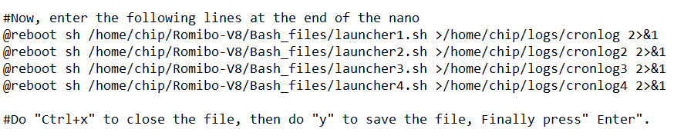

(The sentence with pound sign is the comments, which you do not need to type on the terminal)

6: Restart the CHIP, and the monitor should be able to display the eyes emotion automatically:

**Do the following on terminal:**

